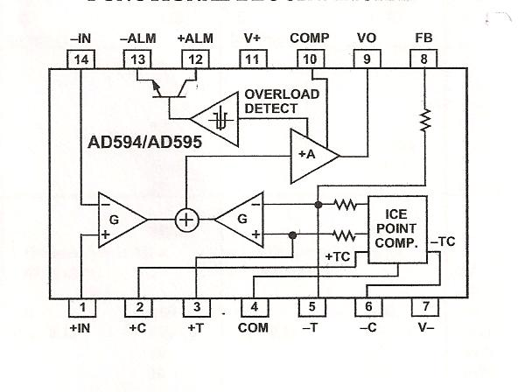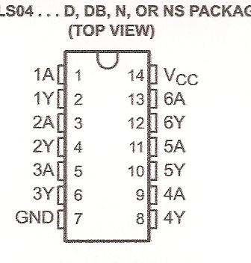
+5V
GND
Type K thermocouple 1
Type K thermocouple 2
20kOhms
20kOhms
A1
S1
AD595
AD595
7404
7404
1 2
3 4
7404
A2
S2

